Asimov The Hugo Winners Vol 4. Doubleday Stated First Ed 1985 Firat Print per gutter code AA6. As new dust jacket in mylar unclipped Price $18.95. As new (unread) hard cover with all 561 pages tightly bound and no marks of any kind. jacket by Kiyoshi Kanai. 8vo (8.5" x 5.75") Contains all thirteen of the Hugo award winning stories from 1976 to 1979, with humorous introductions to each story by Isaac Asimov.
ISBN 0385189346

ID 000185 Price $140.00 Box 2

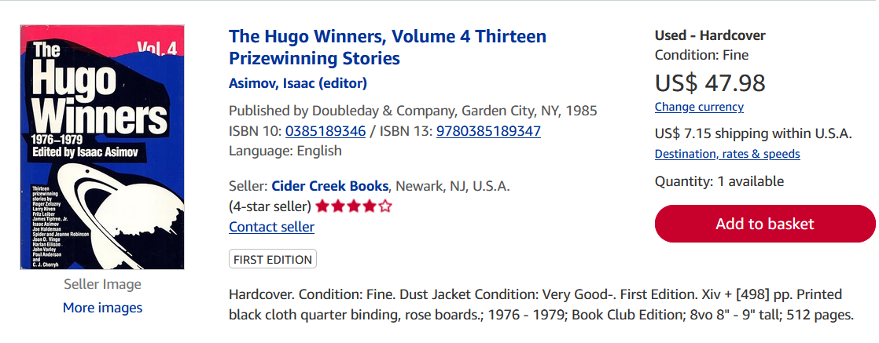
Abe Books

